**Ideation Phase Define the Problem Statements**

|  |  |
| --- | --- |
| Date | 19 October 2022 |
| Team ID | PNT2022TMID26125 |
| Project Name | Inventory Management System for Retailers |
| Maximum Marks | 2 Marks |

**Problem Statement:**

The problem faced by the company is they do not have any systematic system to record and keep their inventory data. It is difficult for the admin to record the inventory data quickly and safely because they only keep it in the logbook and not properly organized.

Good planning and sales forecast before setting optimal inventory levels, appropriate inventory management requires close coordination between the areas of sales, purchasing and finance.

**Example:**

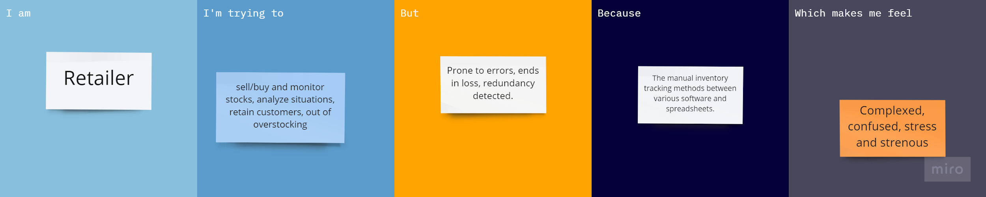

|  |  |  |  |  |  |
| --- | --- | --- | --- | --- | --- |
| **Problem**  **Statement (PS)** | **I am** | **I’m trying to** | **But** | **Because** | **Which makes me feel** |
| PS-1 | Retailer | sell/buy and monitor stocks, analyse situations, retain customers, out of overstocking | Prone to errors, ends in loss,  redundancy detected. | The manual inventory tracking  methods between various software and spreadsheets. | Complexed, confused, stress and strenuous. |